**Full Name: ____________________________**

**Class Exercise Challenge #9 -Switch Statements**

**GAME 2343/2347 and IMED 1345/2345**

After today’s lecture and hands on activities, you will need to complete the following challenge:

1. Create a C# script, call it Switch.cs script, provide a public variable playerCount, data type of int, provide a playerCount, the valid playerCount should be 1 to 2 players. Attached this Switch.cs script to the cube, when the cube is Disable, the Console should print out, “Hello Player One” for one player, “Hello Players” for two players. “Please enter one or two players for everything else”.

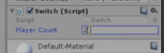

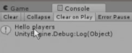

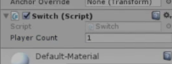

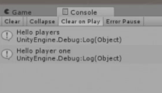

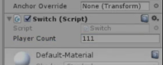

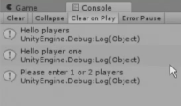

2. Toggle between the two states (checked and unchecked), you will need to take the screen shot, copy and paste it below.

3. You will need to create a folder called LabX_ABcd, where X = number of the lab, A = Upper case your first name initial, and Bcd = full last name with upper case first letter. Separate with an under score between the first initial and lab number. For example: Lab9_DDao.

This folder will contain the entire Unity project and this document. You will need to compress (use only .zip compression) and upload to eCampus.

4. Upload this document to eCampus before the due date.